**IMPORTANCE OF EDUCATION**

**TO GET FINANCIAL FREEDOM:**

Education helps the economy thrive. You benefit your society and your country by educating yourself, your kids and others as every state aspires to an educated **society in the future. Educated individuals always find ways to give back to the** community, whether by investing in college so other student can educate themselves or by investing in the education system.

**TO KNOW THE WORLD:**

The impact of education on every corner of the world is unremarkable. Growth and independent are what we want and what we can achieve with education by our side. Further educated individuals will follow their families, steps and educate their children. If one who educated, they know all the cultures and traditions across the world.

**TO GET GOOD JOB:**

Educated people get more opportunities than others. And they get a job undoubtedly. It opens door to a wider range of career paths and provides the specialized skills needed to succeed in various professions.it help personal growth and develop problem solving skills. Education equips individuals with the knowledge and skills.

***CONFIDENCE PERSON:***

Self-confidence gets a boost! Self-confidence are the ultimate ingredients for success. If you get a right education, you will Have more confidence than others. The courage to take the first step and the confidence that the step taken is in the right direction comes with education. If one who educated, they know all the cultures and traditions across the world. Education helps to know the world better than others.

**PASSPORT TO FUTURE:**

Education is what remains after one has forgotten what one has learned in school, college or any institution. An investment in knowledge pays the best interest. Education is the passport to the future, for tomorrow belongs to those who prepare for it today. Dr. APJ Abdul kalam said, Education is the most powerful weapon which you can use to change the world.

**IMPACTS OF EDUCATION**

Finding a job is probably one of the most common reasons people choose to pursue a college degree, as we are all well aware of the difficulties of landing a good job. In most cases, tens of candidates are applying for the same position, and a college degree can help set you apart from others. In addition, a college education will create more employment opportunities as you will be qualified for more than low-paying and entry-level jobs. It impacts on

* **IMPROVING SELF-DISCIPLINE**
* **SECURING A BETTER INCOME**
* **LEADING TO CAREER ADVANCEMENT**
* **CREATING MORE EMPLOYMENT OPPORTUNITIES**

**DEVELOPING CRITICAL-THINKING SKILLS**

If you have already joined the workforce and love your job, you might think you don’t need to pursue a college or university education. We are here to tell you that a college degree can have other benefits than just landing you a job. By receiving higher education, you gain the knowledge and skills that will give you a competitive edge and allow you to advance your career in a chosen field. It develops

1. **Spreading Awareness**
2. **Enhancing Productivity**
3. **Offering the Opportunity to Socialize and Network**
4. **Pursuing a Passion**
5. **Opening Your Horizons**
6. **Contributing to the Community**

|  |  |
| --- | --- |
| A picture of a winding road and trees  IMPORTANCE OF EDUCATION  FOR BETTER LIFE…... | Abstract  The World Bank Group is the largest financier of education in the developing world, working in 85 countries and committed to helping them reach SDG4: access to inclusive and equitable quality education and lifelong learning opportunities for all by 2030.  EDUCATION |

**NATIONAL EDUCATION DAY**

National Education Day is celebrated on November 11 every year in honour of **Maulana Abul Kalam Azad,** the first Education Minister of independent India and a prominent educationist.

With 65% of the nation's population under the age of 35, it is crucial to provide them with opportunities for quality education and skills development. The Government of India is dedicated to building strong education.

**NEP 2020:** Under the dynamic leadership of Prime Minister Narendra Modi, the Union Cabinet of India approved the National Education Policy (NEP) 2020 on July 29, 2020.

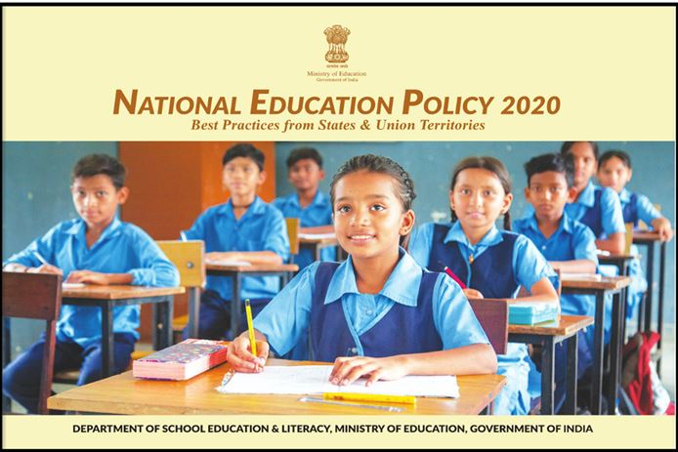

**ONLINE EDUCATION**

**SWAYAM Plus:** SWAYAM Plus, which was officially launched on 27th February 2024 by Shri Dharmendra Pradhan, Hon'ble Minister of Education. The initiative seeks to revolutionize higher education and improve employability by implementing an innovative credit recognition system.

**Duolingo:** Online education apps are mobile applications designed to provide educational content and learning experiences. They offer a variety of features like video lectures, interactive quizzes, and online classes, making learning more accessible and engaging.

**Google Classroom** is a free blended learning platform

developed by Google for educational institutions that aims to simplify creating, distributing, and grading assignments. It uses very effectively on online education.

**INVESTING IN EDUCATION FOR A BRIGHTER FUTURE**

India’s path to global leadership is closely linked to the strength of its education system. To expand access to quality education and build a resilient learning environment, the Department of School Education & Literacy has been allocated a record ₹73,498 crore in the FY 2024-25 budget. This represents a substantial increase of ₹12,024 crore (19.56%) over the Revised Estimate for FY 2023-24, highlighting the government’s commitment to bolstering the education sector.

|  |  |  |  |  |  |  |
| --- | --- | --- | --- | --- | --- | --- |
| **S.NO** | **state** | **census** | **NSC survey** | **female** | **male** | Total |
| 1 | **Tamil Nadu** | **80.09** | 86.77 | 73.44 | **82.9** | 6949.409 |
| 2 | **Kerala** | **94** | 96.11 | 91.07 | **96.2** | 9034.34 |
| 3 | **Mizoram** | **99.01** | 93.35 | 89.27 | **99.01** | 9242.584 |
| 4 | **Karnataka** | **75.36** | 82.47 | 68.08 | **77.2** | 6214.939 |
| 5 | **Goa** | **88.7** | 92.65 | 84.66 | **87.4** | 8218.055 |

Notably, the highest-ever allocations have been made to key autonomous bodies, with ₹ 9,302 crore allocated to Kendriya Vidyalayas (KVS) and ₹ 5,800 crore to Navodaya Vidyalayas (NVS). This substantial investment reflects a clear intent to further elevate India’s education system.

.

For FY 2024-25, the Department of Higher Education's budget allocation is set at Rs. 47,619.77 crore, with Rs. 7,487.87 crore dedicated to schemes and Rs. 40,131.90 crore for non-scheme expenses. This reflects a significant increase of Rs. 3,525.15 crore, or 7.99%, over the previous fiscal year. Notably, the allocation for specific schemes has risen by Rs. 1,139.99 crore, underscoring a strengthened focus on targeted initiatives within higher education.